**DAILY ONLINE ACTIVITIES SUMMARY**

|  |  |  |  |  |  |  |  |  |
| --- | --- | --- | --- | --- | --- | --- | --- | --- |
| **Date:** | **16/06/2020** | | | | | **Name:** | **NAIPUNYA VINOD NAIK** | |
| **Sem & Sec** | **IV SEM & A SECTION** | | | | | **USN:** | **4AL18CS050** | |
| **Online Test Summary** | | | | | | | | |
| **Subject** | | **COMPLEX ANALYSIS , PROBABILITY AND STATISTICAL METHODS** | | | | | | |
| **Max. Marks** | | **30** | | **Score** | | | **22** | |
| **Certification Course Summary** | | | | | | | | |
| **Course** | **A BEGGINERS TO MICROSOFT EXCEL** | | | | | | | |
| **Certificate Provider** | | | **UDEMY** | | **Duration** | | | **5 HRS** |
| **Coding Challenges** | | | | | | | | |
| **Problem Statement:- 1)** [Write a Python program to check whether a given a binary tree is a valid binary search tree (BST) or not?](https://github.com/orgs/alvas-education-foundation/teams/cse/discussions/71)  **2)** Write a C Program to implement the Binary Reversal. | | | | | | | | |
| **Status:- EXECUTED** | | | | | | | | |
| **Uploaded the report in Github** | | | | | **YES** | | | |
| **If yes Repository name** | | | | | <https://github.com/naipunya-naik/lockdown-coding/blob/master/PYTHON%20CODING/bst_16-06-2020.py>  <https://github.com/naipunya-naik/lockdown-coding/blob/master/C%20CODING/binaryreverse_14-06-2020.c> | | | |
| **Uploaded the report in slack** | | | | | **YES** | | | |

Online Test Details: (Attach the snapshot and briefly write the report for the same).

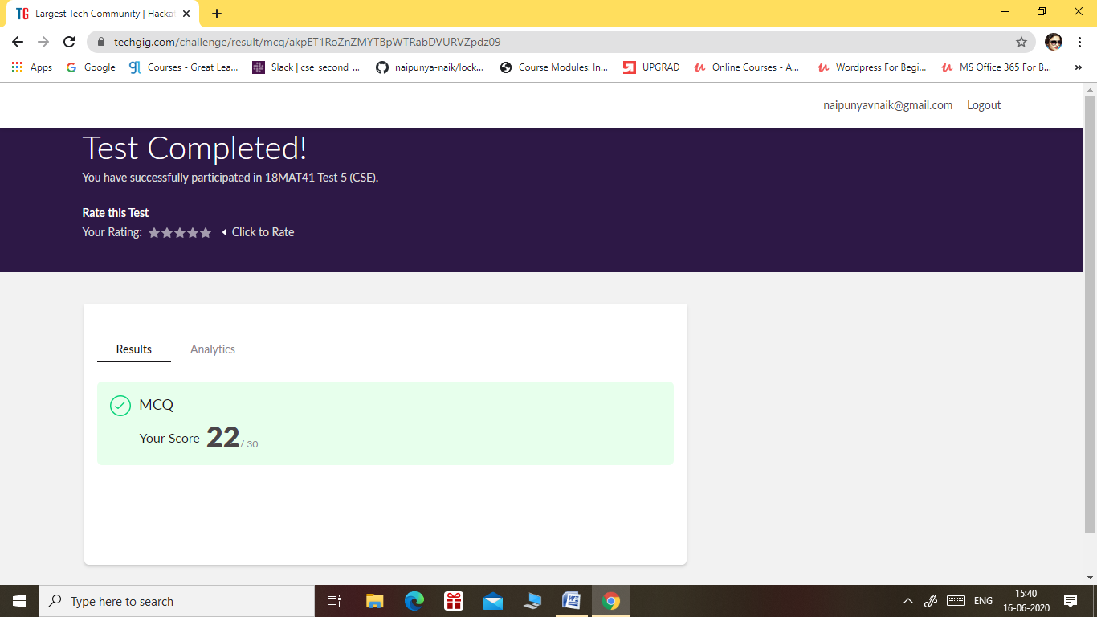

* THE 5TH I.A TEST OF COMPLEX ANALYSIS, PROBABILITY AND STATISTICAL METHODS WAS CONDUCTED ON 16 JUNE 2020.
* SUBJECT:- COMPLEX ANALYSIS,PROBABILITY AND STATISTICAL METHODS
* SYLLABUS:- MODULE 1
* START TIME:- 3.00 PM
* END TIME:- 3.40 PM
* DURATION:- 40 MIN
* NO.OF QUESTIONS:- 15
* EACH QUESTION CARRIED 2 MARKS.

Certification Course Details: (Attach the snapshot and briefly write the report for the same).

CERTIFICATION COURSE NAME:- A BEGINNERS TO MICROSOFT EXCEL

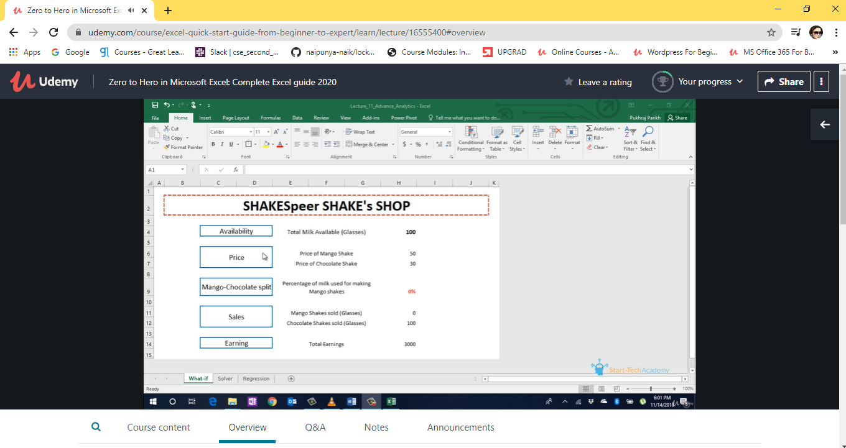

TOPICS COVERED ON 16 JUNE 2020:-

* **Section 8: Pivot Charts**
* **Section 9: Named Ranges**
* **Section 10: Excel Shortcuts**
* **Section 11: Macros**
* **Section 12: Advanced Excel**
* **Section 13: Bonus Section**

Coding Challenges Details: (Attach the snapshot and briefly write the report for the same)

PROBLEM STATEMENT 1:- [Write a Python program to check whether a given a binary tree is a valid binary search tree (BST) or not?](https://github.com/orgs/alvas-education-foundation/teams/cse/discussions/71)

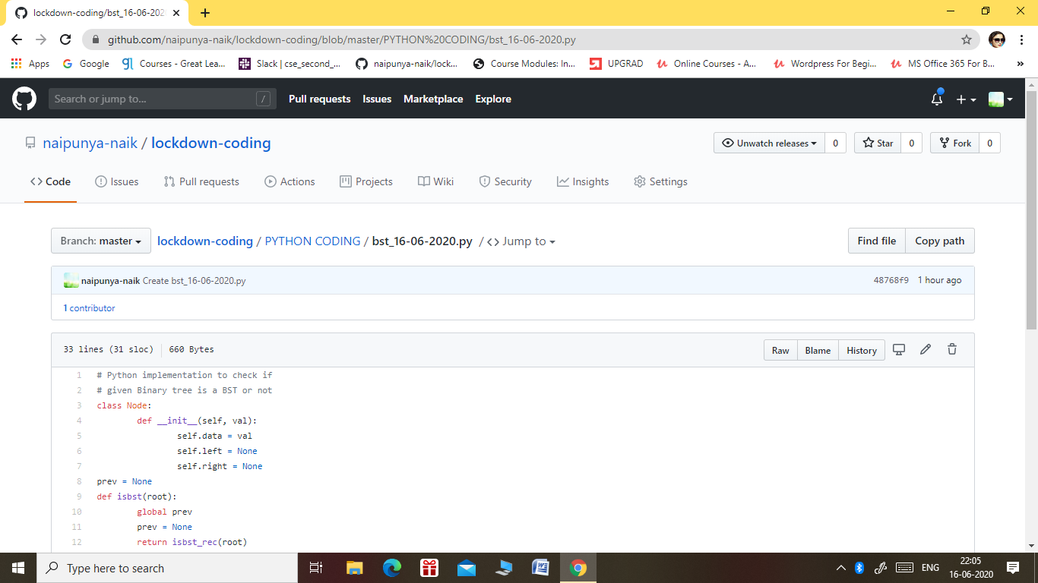

GITHUB REPOSITORY LINK:-

<https://github.com/naipunya-naik/lockdown-coding/blob/master/PYTHON%20CODING/bst_16-06-2020.py>

PROBLEM STATEMENT 2:- Write a C Program to implement the Binary Reversal.

Top of Form

Bottom of Form

|  |
| --- |
| Have the function BinaryReversal(str) take the str parameter being passed, which will be a positive integer, take its binary representation, reverse that string of bits, and then finally return the new reversed string in decimal form. For example: if str is 47 then the binary version of this integer is 101111 but we pad it to be 00101111 (Total number of bits must be multiples of 4). Your program should reverse this binary string which then becomes: 11110100 and then finally return the decimal version of this string, which is 244.  Examples  Input: 213 Output: 171  Input: 4567 Output: 60296  Screenshot (142).png |

GITHUB REPOSITORY LINK:-

<https://github.com/naipunya-naik/lockdown-coding/blob/master/C%20CODING/binaryreverse_14-06-2020.c>